

# 

### Semester One Examination, 2019

### Question/Answer booklet

# MATHEMATICS

If required by your examination administrator, please place your student identification label in this box

**METHODS**

**UNIT 3**

## Section Two:

## Calculator-assumed

|  |  |  |  |  |  |  |  |  |  |  |
| --- | --- | --- | --- | --- | --- | --- | --- | --- | --- | --- |
| Student number: In figures |  |  |  |  |  |  |  |  |  |  |

In words

Your name

## Time allowed for this section

Reading time before commencing work: ten minutes

Working time: one hundred minutes

## Materials required/recommended for this section

***To be provided by the supervisor***

This Question/Answer booklet

Formula sheet (retained from Section One)

***To be provided by the candidate***

Standard items: pens (blue/black preferred), pencils (including coloured), sharpener,  
correction fluid/tape, eraser, ruler, highlighters

Special items: drawing instruments, templates, notes on two unfolded sheets of A4 paper, and up to three calculators approved for use in this examination

## Important note to candidates

No other items may be taken into the examination room. It is **your** responsibility to ensure that you do not have any unauthorised material. If you have any unauthorised material with you, hand it to the supervisor **before** reading any further.

## Structure of this paper

|  |  |  |  |  |  |
| --- | --- | --- | --- | --- | --- |
| Section | Number of questions available | Number of questions to be answered | Working  time (minutes) | Marks available | Percentage of examination |
| Section One:  Calculator-free | 8 | 8 | 50 | 52 | 35 |
| Section Two:  Calculator-assumed | 13 | 13 | 100 | 98 | 65 |
|  | | |  | **Total** | 100 |

## Instructions to candidates

1. The rules for the conduct of examinations are detailed in the school handbook. Sitting this examination implies that you agree to abide by these rules.

2. Write your answers in this Question/Answer booklet preferably using a blue/black pen.  
Do not use erasable or gel pens.

3. You must be careful to confine your answer to the specific question asked and to follow any instructions that are specified to a particular question.

4. Show all your working clearly. Your working should be in sufficient detail to allow your answers to be checked readily and for marks to be awarded for reasoning. Incorrect answers given without supporting reasoning cannot be allocated any marks. For any question or part question worth more than two marks, valid working or justification is required to receive full marks. If you repeat any question, ensure that you cancel the answer you do not wish to have marked.

5. It is recommended that you do not use pencil, except in diagrams.

6. Supplementary pages for planning/continuing your answers to questions are provided at the end of this Question/Answer booklet. If you use these pages to continue an answer, indicate at the original answer where the answer is continued, i.e. give the page number.

7. The Formula sheet is not to be handed in with your Question/Answer booklet.

Section Two: Calculator-assumed 65% (98 Marks)

This section has**thirteen (****13)** questions. Answer **all** questions. Write your answers in the spaces provided.

Working time: 100 minutes.

Question 9 (5 marks)

Fuel flows into a storage tank that is initially empty at a rate of $\sqrt{9+4t}$ litres per minute, where $t$ is the time in minutes and $0≤t≤110$.

(a) Determine how much fuel is in the tank after $18$ minutes. (2 marks)

(b) If the tank is completely full after $110$ minutes, determine the time required for the tank to become one-fifth full. (3 marks)

Question 10 (7 marks)

$X$ is a uniform discrete random variable where $x=1, 2, 3, 4, 6, 8, 11$.

(a) Determine

(i) $P(X≥3)$. (1 mark)

(ii) $P\left(X>2 \right| X≤8)$. (2 marks)

(b) Calculate the exact value of

(i) $E⁡(X)$. (2 marks)

(ii) $\operatorname{Var}{(X)}$. (2 marks)

Question 11 (8 marks)

The potential difference, $V$ volts, across the terminals of an electrical capacitor $t$ seconds after it begins to discharge through a resistor can be modelled by the equation

$$V=V_{0}e^{-kt}$$

$V_{0}$ is the initial potential difference and $k$ is a constant that depends on the size of the capacitor and the resistor.

(a) If $V_{0}=22.6$ volts and $k=0.018$, determine

(i) the potential difference across the capacitor $4$ minutes after discharge began.

(2 marks)

(ii) the time taken for the potential difference to drop from $17.5$ to $12.5$ volts. (3 marks)

(iii) the rate of change of $V$ when the potential difference is $20$ volts. (1 mark)

(b) Another capacitor takes $66$ seconds for its maximum potential difference to halve. It is instantly recharged to its maximum every $3$ minutes, which is the time required for the potential difference to fall from its maximum to $1.8$ volts. Determine the maximum potential difference for this capacitor. (2 marks)

Question 12 (8 marks)

A manufacturing process begins and the rate at which it produces gas after $t$ minutes ($t≥0$) is modelled by

$$r\left(t\right)=45\left(1-e^{-0.4t}\right) {\text{m}}^{3}/\text{minute}$$

(a) State the maximum rate that gas can be produced at. (1 mark)

(b) Calculate the rate that gas is being produced after $2$ minutes. (1 mark)

(c) Use the increments formula to determine the approximate change in $r$ between $30$ and $33$ seconds after production began. (3 marks)

(d) Use the increments formula to determine the approximate volume of gas produced in the $5$ seconds following $t=2$. (3 marks)

Question 13 (5 marks)

The function $f\left(x\right)=\begin{matrix}1 \\ \overline{2^{x}}\end{matrix}$ is shown below.

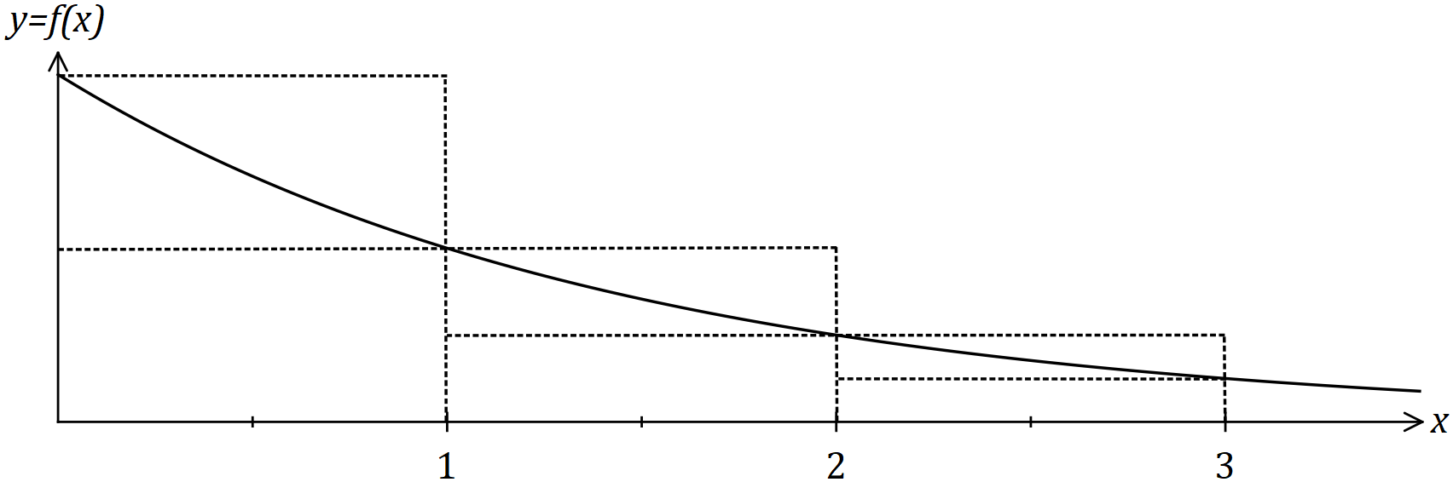

(a) Use the sum of the areas of the inscribed rectangles shown in the diagram to explain why $\int_{0}^{3}{\underset{ }{\overset{ }{f(x)}}}dx>\begin{matrix}7 \\ \overline{8}\end{matrix}$ . (2 marks)

(b) Use the average of the sum of the areas of the inscribed rectangles and the sum of the areas of the circumscribed rectangles shown to determine an estimate for $\int_{0}^{3}{\underset{ }{\overset{ }{f(x)}}}dx$.

(2 marks)

(c) Suggest a modification to the method used in (b) to achieve a better estimate for $\int_{0}^{3}{\underset{ }{\overset{ }{f(x)}}}dx$. (1 mark)

Question 14 (7 marks)

Let $f\left(x\right)=3+e^{-0.2x-2}$.

(a) Sketch the graph of $y=f(x)$ on the axes below. (2 marks)

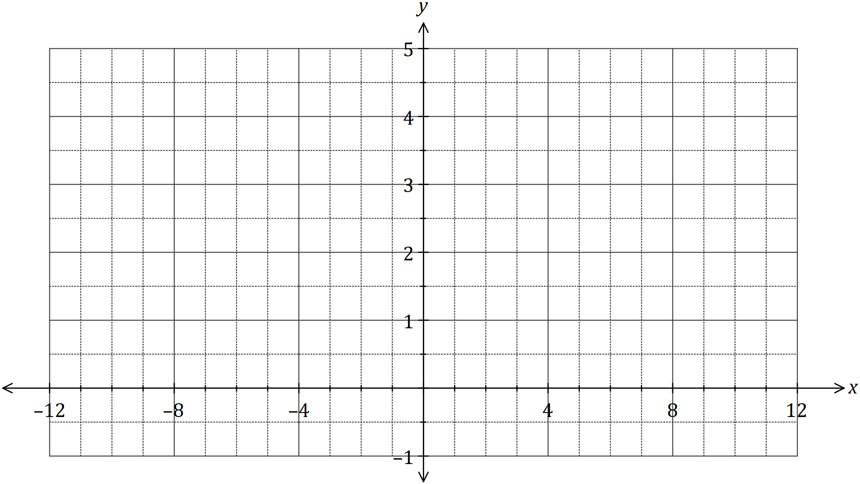

(b) The line $y=2-0.2x$ is tangential to the curve $y=f(x)$ at $x=-10$, and it intersects the $x$-axis at the point $(k, 0)$. Add the line to the graph above and shade the area enclosed by the line, the curve and $x=k$. (2 marks)

(c) Determine the area enclosed by the line, the curve and $x=k$. (3 marks)

Question 15 (7 marks)

The graph of $y=f(x)$ is shown below for $-4≤x≤5$.

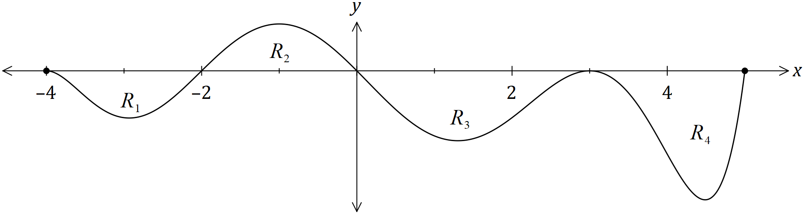

The area trapped between the $x$-axis and the curve for regions $R_{1}, R_{2}, R_{3}$ and $R_{4}$ are $21, 25, 43$ and $32$ square units respectively.

(a) Determine the value of

(i) $\int_{0}^{3}{\underset{ }{\overset{ }{f(x)}}}dx$. (1 mark)

(ii) $\int_{-2}^{5}{\underset{ }{\overset{ }{f(x)}}}dx$. (2 marks)

(iii) $\int_{-2}^{3}{\underset{ }{\overset{ }{\left(2-f(x)\right)}}}dx$. (2 marks)

(iv) $\int_{-4}^{0}{\underset{ }{\overset{ }{f(x)}}}dx+\int_{0}^{5}{\underset{ }{\overset{ }{f'(x)}}}dx$. (2 marks)

Question 16 (12 marks)

The random variable $X$ is the number of goals scored by a team in a soccer match, where

$$P\left(X=x\right)=\frac{{2.2}^{x}e^{-2.2}}{x!} \text{for} x=0, 1, 2, 3, …\text{to infinity}$$

(a) Determine the probability that the team scores at least one goal in a match. (2 marks)

The random variable $Y$ is the bonus each player is paid after a match, depending on the number of goals the team scored. For four or more goals $\$500$ is paid, for two or three goals $\$250$ is paid and for one goal $\$100$ is paid. No bonus is paid if no goals are scored.

(b) Complete the probability distribution table for $Y$. (3 marks)

|  |  |  |  |  |
| --- | --- | --- | --- | --- |
| Goals scored | $$x=0$$ | $$x=1$$ | $$2≤x≤ 3$$ | $$x≥4$$ |
| $$y (\$)$$ | $$0$$ |  |  | $$500$$ |
| $$P(Y=y)$$ |  |  |  | $$0.1806$$ |

(c) Calculate

(i) the mean bonus paid per match. (2 marks)

(ii) the standard deviation of the bonus paid per match. (2 marks)

(d) The owner of the team plans to increase the current bonuses by $\$50$ next season (so that the players will get a bonus of $\$50$ even when no goals are scored) and then further raise them by $12\%$ the following season. Determine the mean and standard deviation of the bonus paid per match after both changes are implemented. (3 marks)

Question 17 (9 marks)

Seeds were planted in rows of five and the number of seeds that germinated in each of the $120$ rows are summarised below.

|  |  |  |  |  |  |  |
| --- | --- | --- | --- | --- | --- | --- |
| Number of germinating seeds | $$0$$ | $$1$$ | $$2$$ | $$3$$ | $$4$$ | $$5$$ |
| Number of rows | $$1$$ | $$1$$ | $$3$$ | $$16$$ | $$46$$ | $$53$$ |

(a) Use the results in the table to determine

(i) the probability that no more than $4$ seeds germinated in a randomly selected row.

(1 mark)

(ii) the mean number of seeds that germinated per row. (1 mark)

(b) Another row of five seeds is planted. Determine the probability that no more than $4$ seeds germinate in this row if the number that germinate per row is binomially distributed with the above mean. (2 marks)

Suppose it is known that $66\%$ of all seeds planted will germinate and that seeds are now planted in rows of $16$.

(c) Assuming that seeds germinate independently of each other, determine

(i) the most likely number of seeds to germinate in a row. (1 mark)

(ii) the probability that at least $9$ seeds germinate in a randomly chosen row.

(2 marks)

(iii) the probability that in eight randomly chosen rows, exactly six rows have at least $9$ seeds germinating in them. (2 marks)

Question 18 (9 marks)

The graph of $y=f(x)$ is shown below.

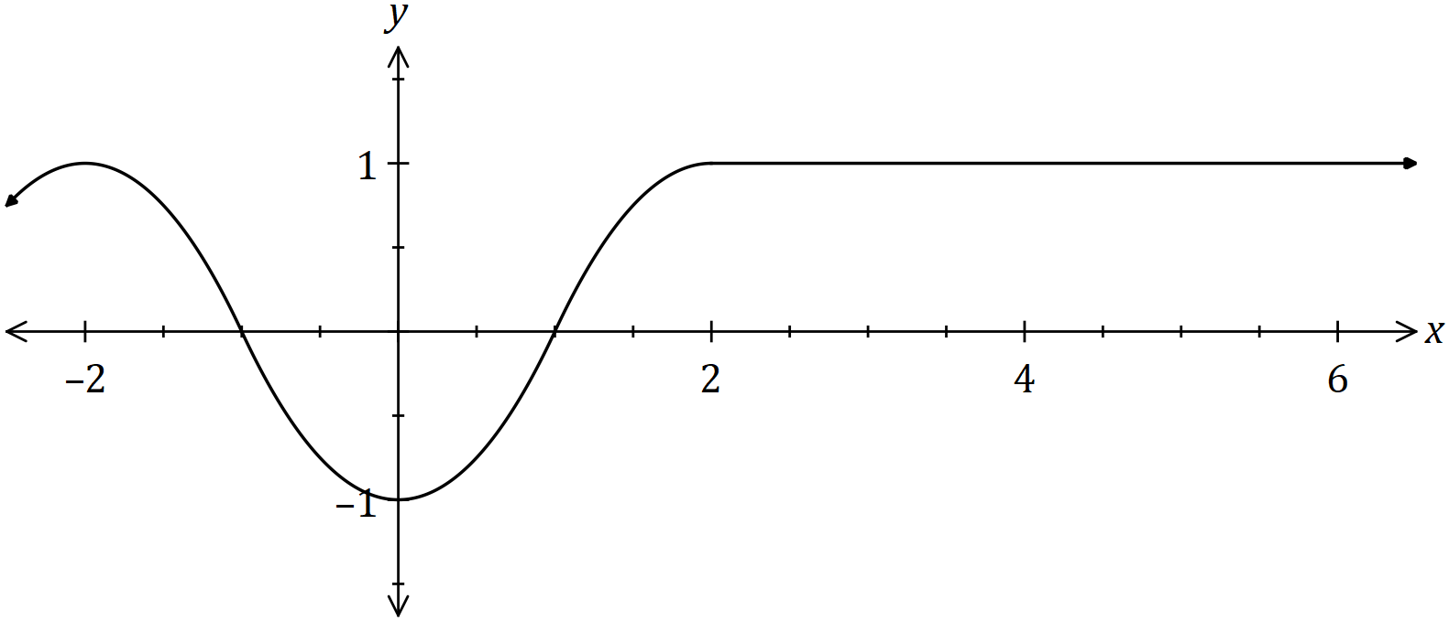

Let $A(x)$ be defined by the integral $A\left(x\right)=\int_{-2}^{x}{\underset{ }{\overset{ }{f(t)}}}dt$ for $x≥-2$.

(a) Use the graph of $y=f(x)$ to identify all the turning points of the graph of $y=A(x)$, stating the $x$-coordinate and nature of each point. (2 marks)

It is also known that the $A\left(2\right)=0$.

(b) Using the graph of $y=f(x)$ or otherwise, explain why $A\left(5\right)=3$. (2 marks)

(c) Sketch the graph of $y=A(x)$ on the axes below, indicating and labelling the location of all key features. (5 marks)

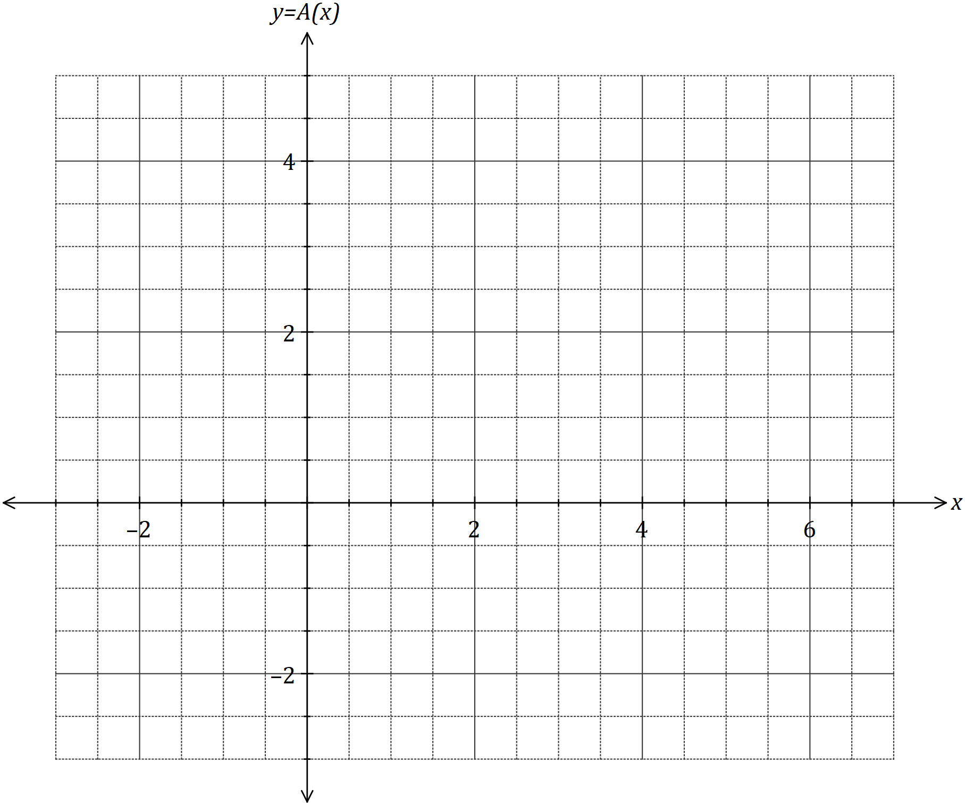

Question 19 (7 marks)

A small body has displacement $x=0$ when $t=6$ and moves along the $x$-axis so that its velocity after $t$ seconds is given by

$$v\left(t\right)=20\sin\left(\frac{πt}{18}\right) \text{cm/s}$$

(a) Determine an equation for $x(t)$, the displacement of the body after $t$ seconds. (3 marks)

(b) Describe, with justification, how the speed of the body is changing when $t=30$. (4 marks)

Question 20 (7 marks)

An aquarium, with a volume of cm3, takes the shape of a rectangular prism with square ends of side $x$ cm and no top. The glass for the base costs $0.05$ cents per square cm and for the four vertical sides costs $0.08$ cents per square cm. The cost of glue to join the edges of two adjacent pieces of glass is $0.6$ cents per cm. Assume the glass has negligible thickness and ignore any other costs.

(a) Show that $C=\begin{matrix}x^{2} \\ \overline{625}\end{matrix}+\begin{matrix}9x \\ \overline{250}\end{matrix}+\begin{matrix}168 \\ \overline{{ x}^{2} }\end{matrix}+\begin{matrix}960 \\ \overline{ x^{2} }\end{matrix}$, where $C$ is the cost, in dollars, to make the aquarium. (4 marks)

(b) Show use of a calculus method to determine the minimum cost of making the aquarium.

(3 marks)

Question 21 (7 marks)

(a) Given that $f\left(t\right)=\sin\left(4t+\frac{π}{4}\right)$ and $F\left(x\right)=\int_{0}^{x}{\underset{ }{\overset{ }{f(t)}}}dt$, determine the exact value of

(i) $F\left(\frac{π}{8}\right)$. (1 mark)

(ii) $F^{'}\left(\frac{π}{8}\right)$. (2 marks)

(b) Given that $G\left(x\right)=\int_{4}^{x}{\underset{ }{\overset{ }{g(t)}}}dt$, $\begin{matrix}d^{2}G \\ \overline{dx^{2}}\end{matrix}=6\sqrt{x}-5$ and $G\left(9\right)=174$, determine $g(t)$. (4 marks)

Supplementary page

Question number: _________

|  |  |  |
| --- | --- | --- |
| Markers use only | | |
| Question | Maximum | Mark |
| 9 | 5 |  |
| 10 | 7 |  |
| 11 | 8 |  |
| 12 | 8 |  |
| 13 | 5 |  |
| 14 | 7 |  |
| 15 | 7 |  |
| 16 | 12 |  |
| 17 | 9 |  |
| 18 | 9 |  |
| 19 | 7 |  |
| 20 | 7 |  |
| 21 | 7 |  |
| S2 Total | 98 |  |
| S2 Wt (×0.6633) | 65% |  |

Student Name: ____________________________________________

© 2019 WA Exam Papers. All Saints' College has a non-exclusive licence to copy and communicate this document for non-commercial, educational use within the school. No other copying, communication or use is permitted without the express written permission of WA Exam Papers. SN001-135-2.